Social Bookmarking
What is it?
- Allows you to organize, store, manage and search for bookmarks of resources online.
- Tags are used to categorize your bookmarks into searchable folders
- They are usually public so choose an anonymous user name if you are worried about this
Creating an Account in Delicious
- Create your account with Facebook or Twitter account – you must do this if you want to be able to import your bookmarks (there are pros and cons to this)
- Create with email but you will not be able to import all your current bookmarks at once.
Add the Bookmarklet:
Go to: http://delicious.com/help/bookmarklets
Drag this icon to your toolbar. When you click on this link while you are on a webpage, it will prompt you to add tags and save the page to your delicious account.
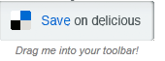
Exporting Bookmarks from Firefox
Step 1: Click on the icon on the top right of your screen
Click on this arrow to see the options
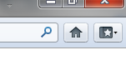
Step 2: Select “Show all Bookmarks”
Step 3: This screen will appear:
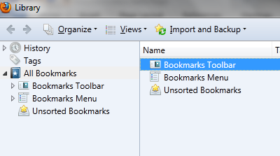
Click on Import and Backup and choose EXPORT HTML
Step 4: Save this file to your H drive ; you can rename it if you’d like
Step 5: Import into delicious.
Exporting Bookmarks from Chrome
Step 1: Click on the wrench near the top right of your screen:
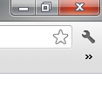
Step 2: Hover over “Bookmarks” and then select “Bookmark Manager”
Step 3: Click on Organize near the top left and select “Export bookmarks to HTML file”
Click here for drop down menu. Chose Export Bookmarks from the bottom of the list
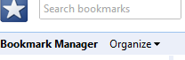

How do I make a link private?
Links you save on Delicious are public by default, but you can also choose to make them private, which means only you will see them. A small "lock" icon will appear next to your private links. You can change the privacy setting on links anytime with the pencil shaped edit button. You can also make multiple links private/public by selecting the checkbox next to each link in your "My Links" and choosing "Make Private" or "Make Public."

