**Twitter Navigation**

Click here for settings, edit profile, help, etc

Search for hashtags or keywords here

Profile – number of Tweets; click to see followers’ names and who you are following.

**Home Page**

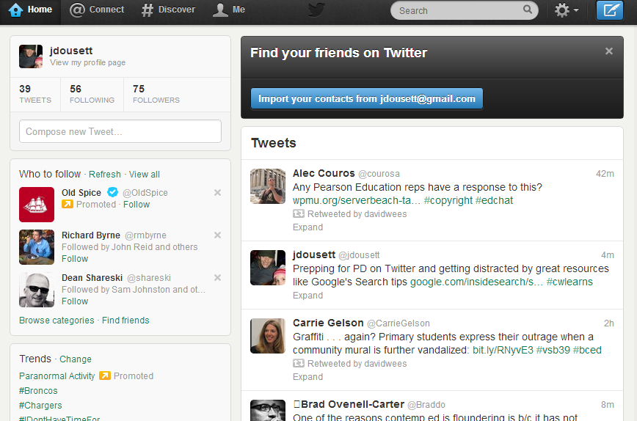

#hashtag chat

Click here to compose a tweet

What’s hot or *trending*on Twitter now.

Who Twitter thinks you should follow

Tweets posted by people you follow